First create backend project spring boot with mysql database

Then create frontend project using angular

using ng command build angular project

using mvn command create jar file for spring boot project.

Then create dockerFile for both frontend and backend project.

Backend project structure

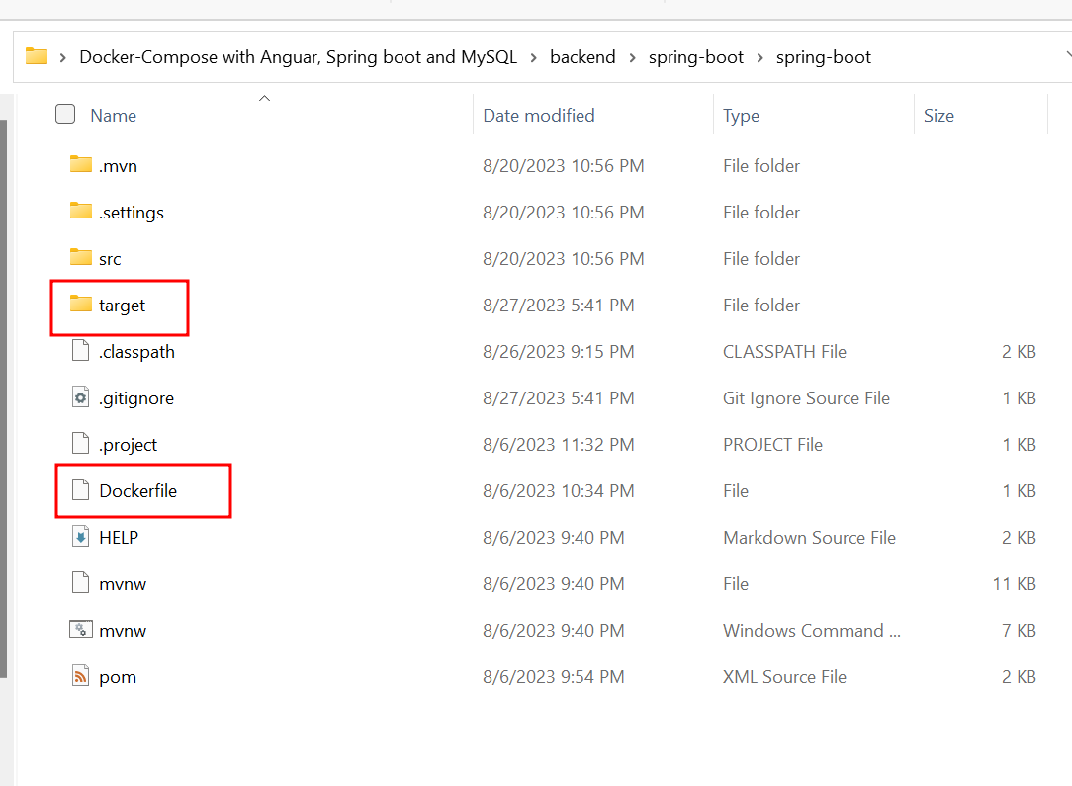

Frontend project structure

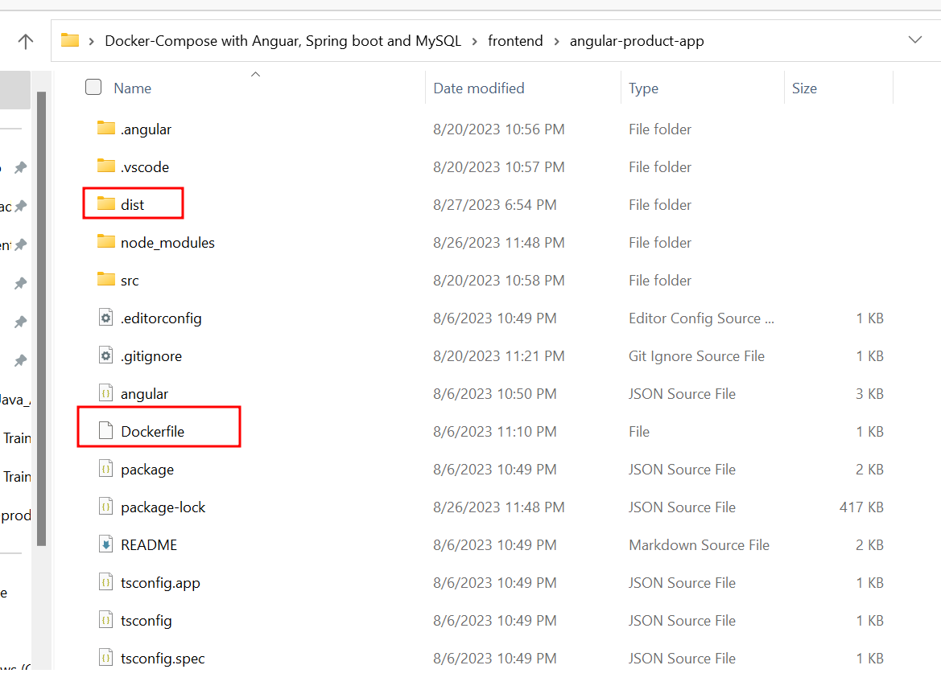

Once development task done in local machine you need to push this project to remove repository

Please create docker-compose.yml file which is responsible to run more than one container

Ie mysql container

Spring boot container

Angular container

version: '3.3'

services:

  mysql-container:

    image: mysql:8

    environment:

      MYSQL_ROOT_PASSWORD: root

      MYSQL_DATABASE: mydb

    ports:

      - 3306:3306

    restart: always

  springboot-container:

    build: ./backend/spring-boot/spring-boot/

    depends_on:

      - mysql-container

    ports:

      - 9090:9090

    restart: always

  angular-container:

    build: ./frontend/angular-product-app/

    ports:

      - 80:80

So inside project folder (which contains backend and frontend create git repository)

git init

git add .

git commit -m “initial project ready”

git remote add origin URL (URL remote repository URL)

git push -u origin main/master

after push please check this code in your remote repository.

Please login to AWS account.

Then search EC2 instance option

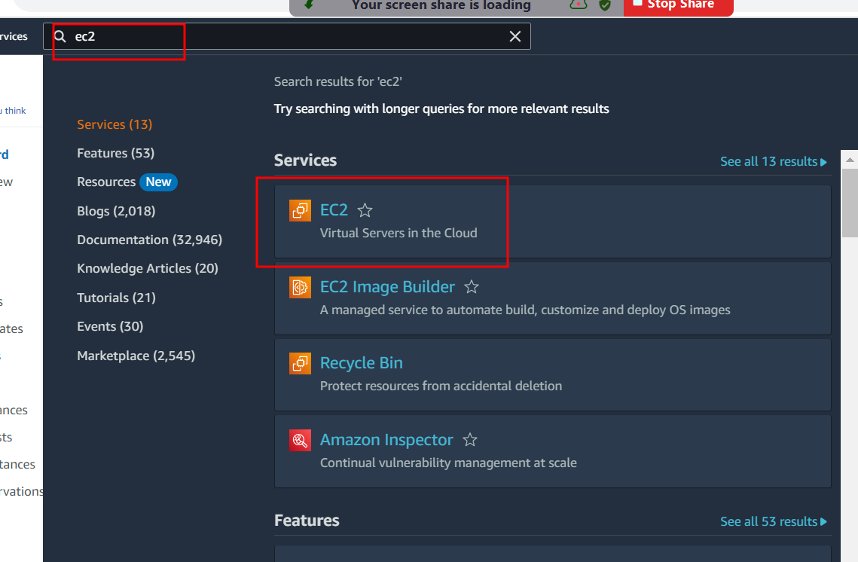

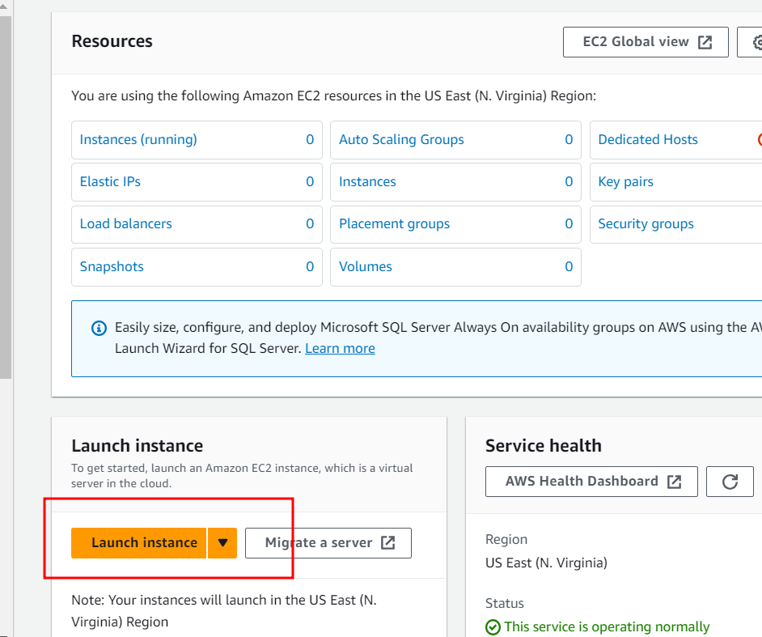

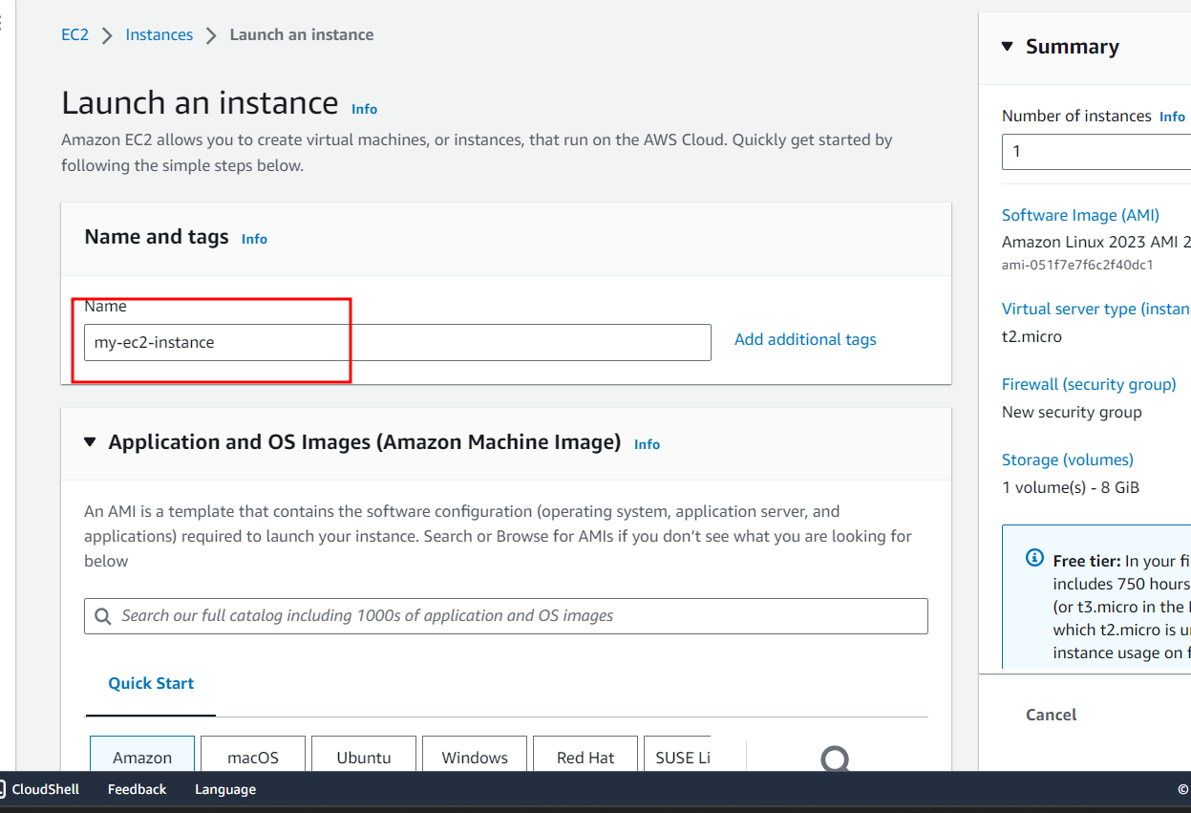

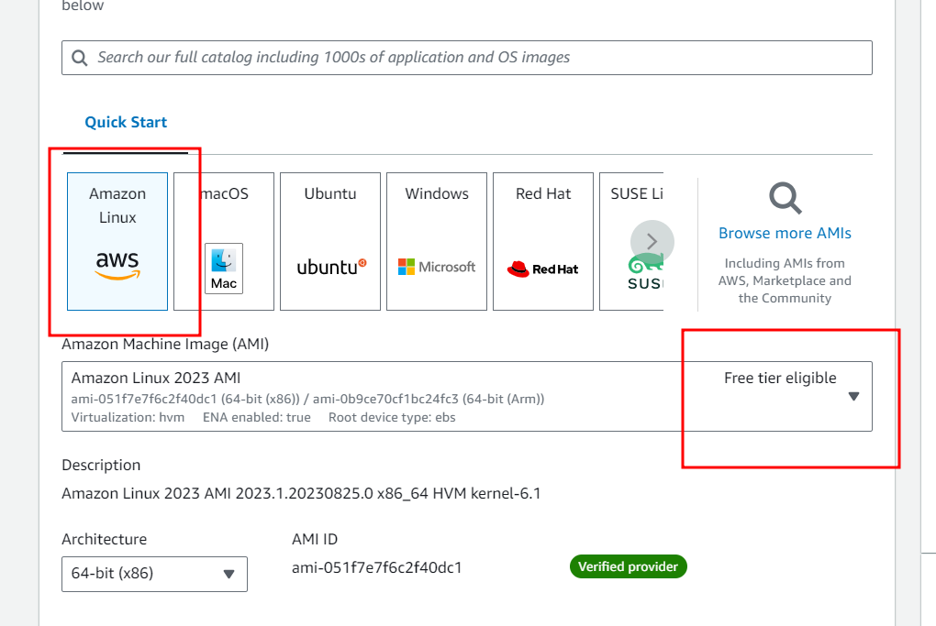

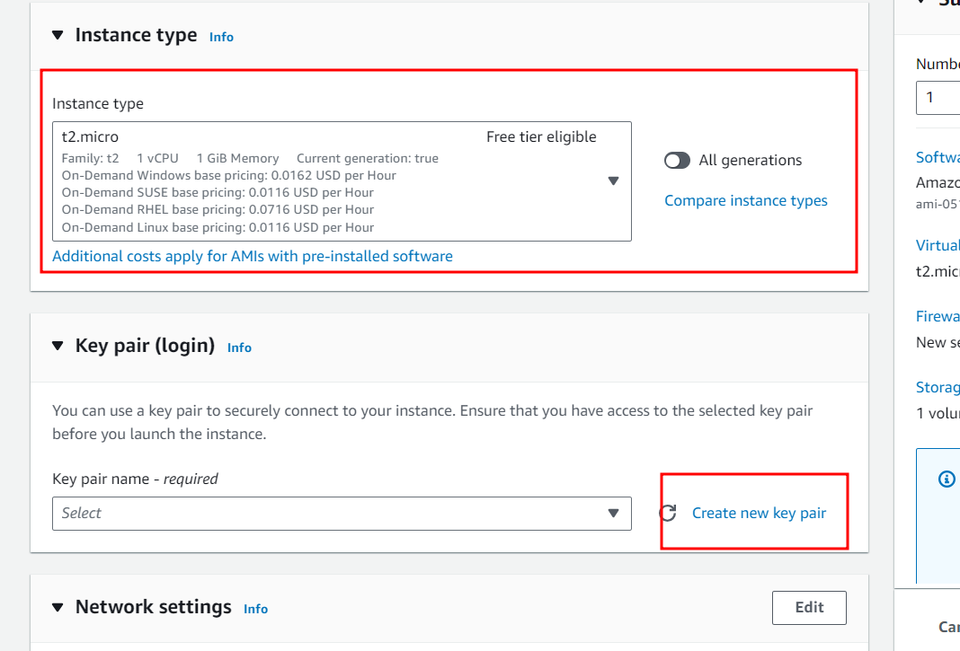

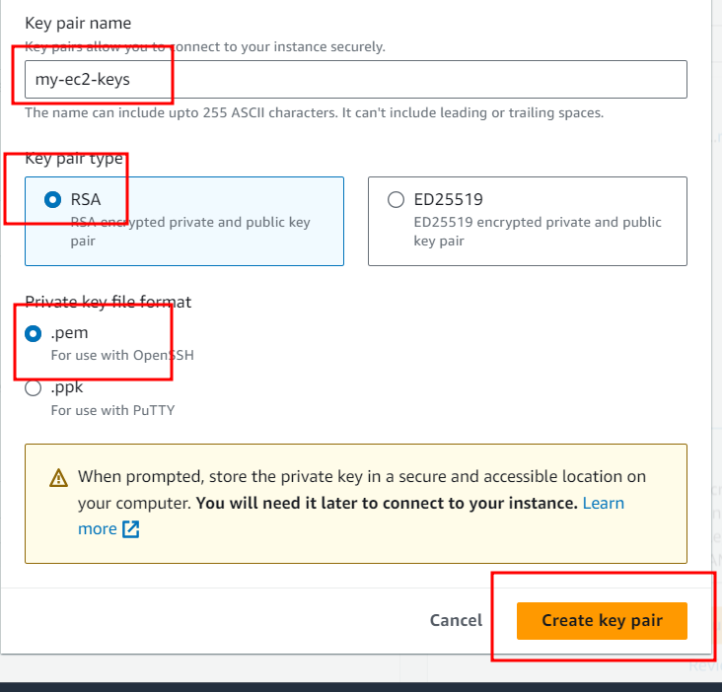

Download key and remember key path.

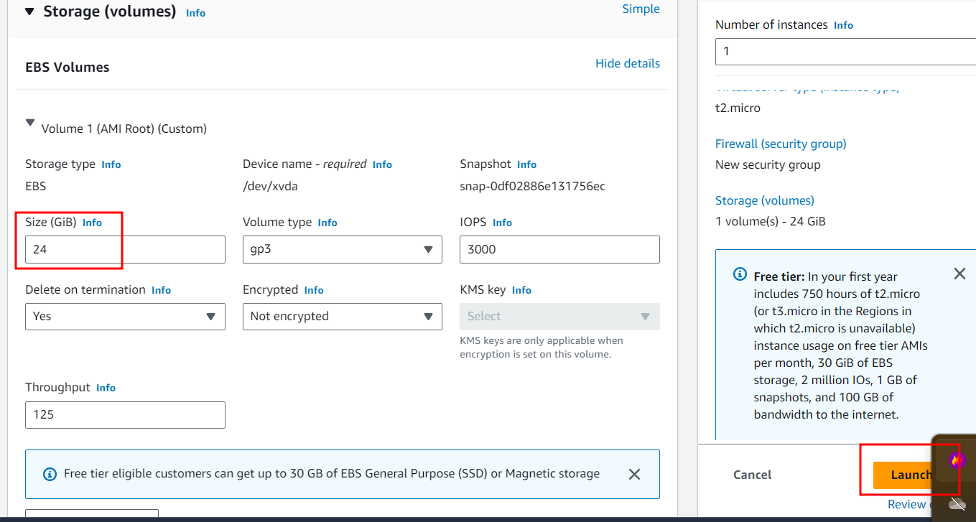

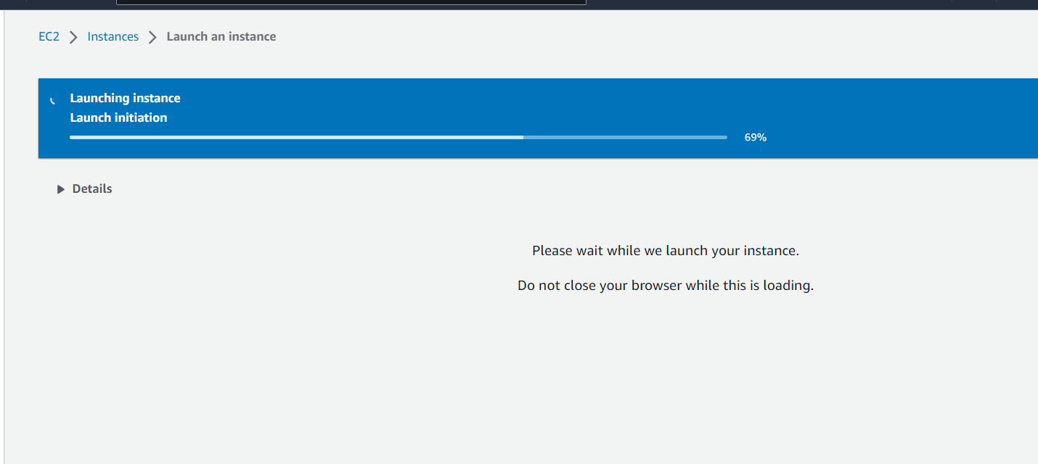

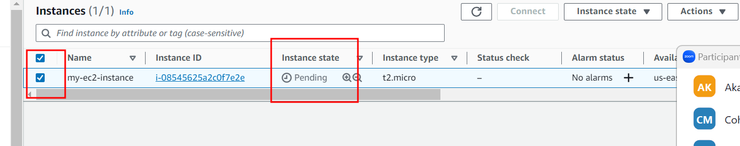

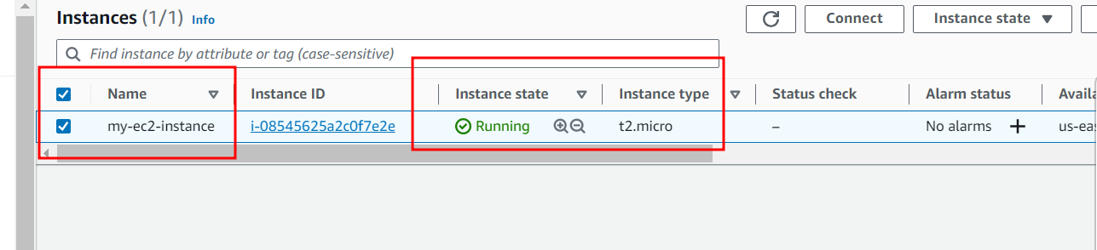

Now in EC2 instance we will open all port

3306 🡪 mysql database

9090🡪 spring boot

80🡪 angular with nginx server

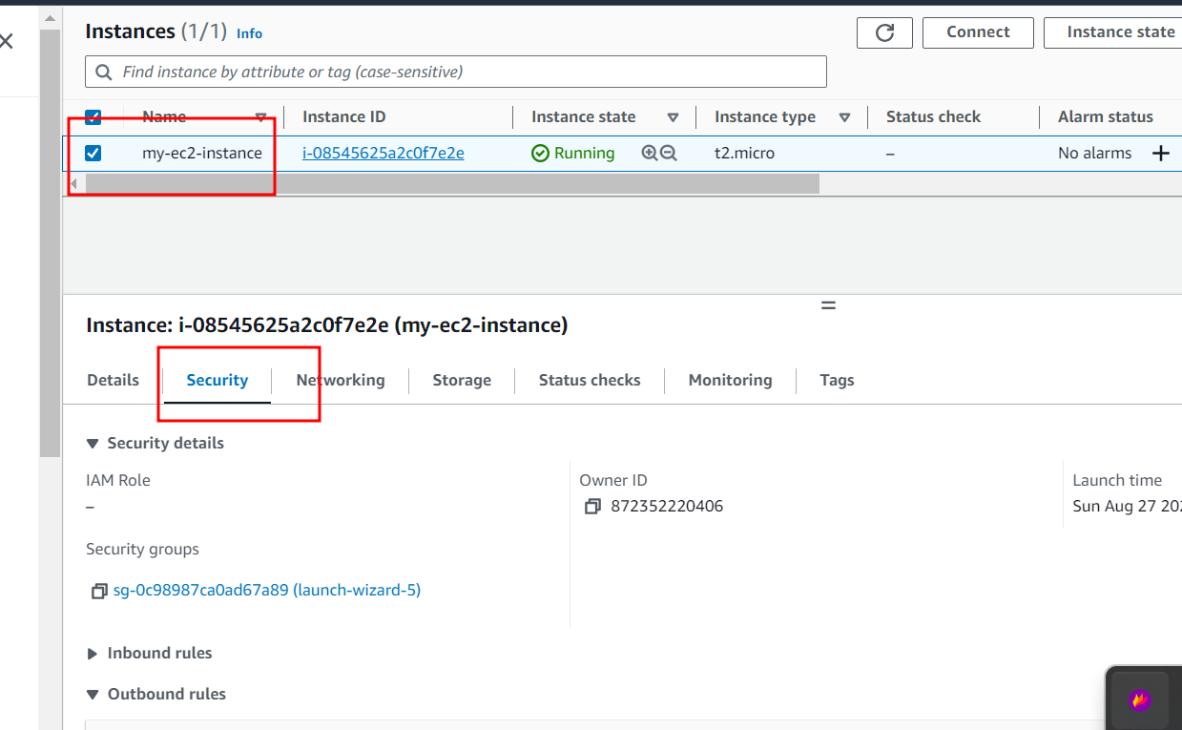

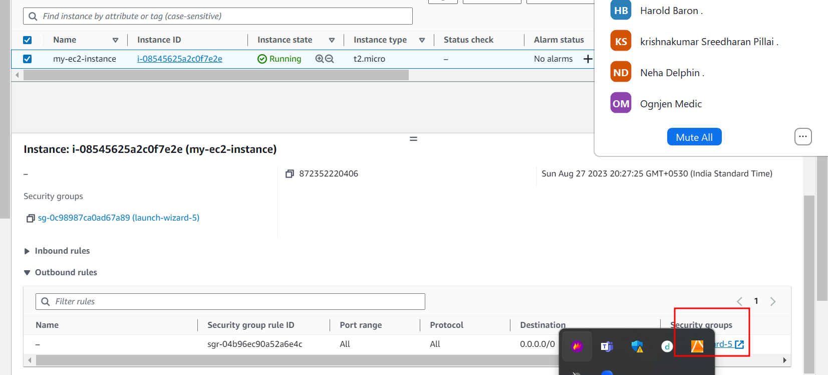

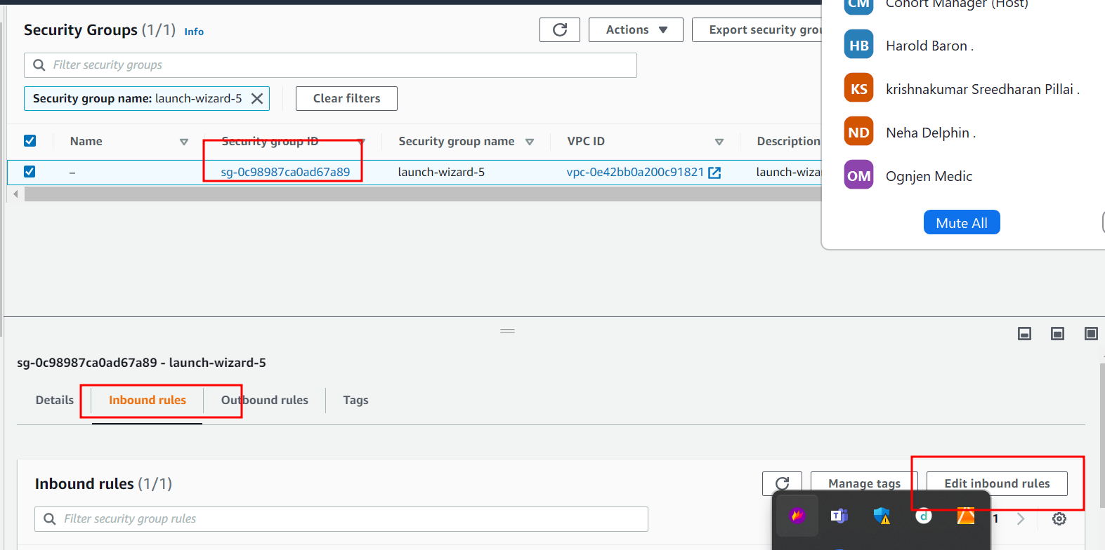

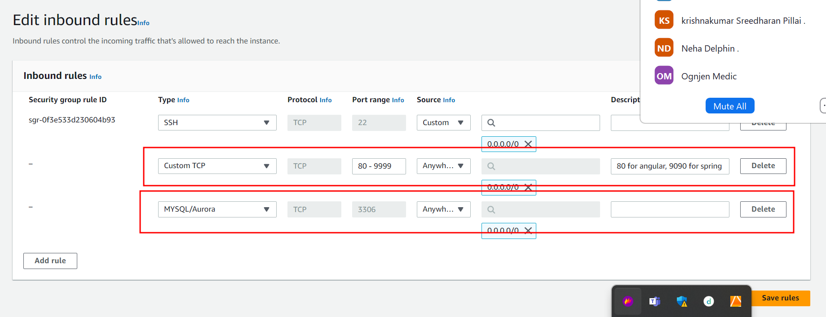

Close security wizard tab.

Now we are going to connect EC2 instance using terminal

Ie git bash (for window user)

Non window user (normal terminal)

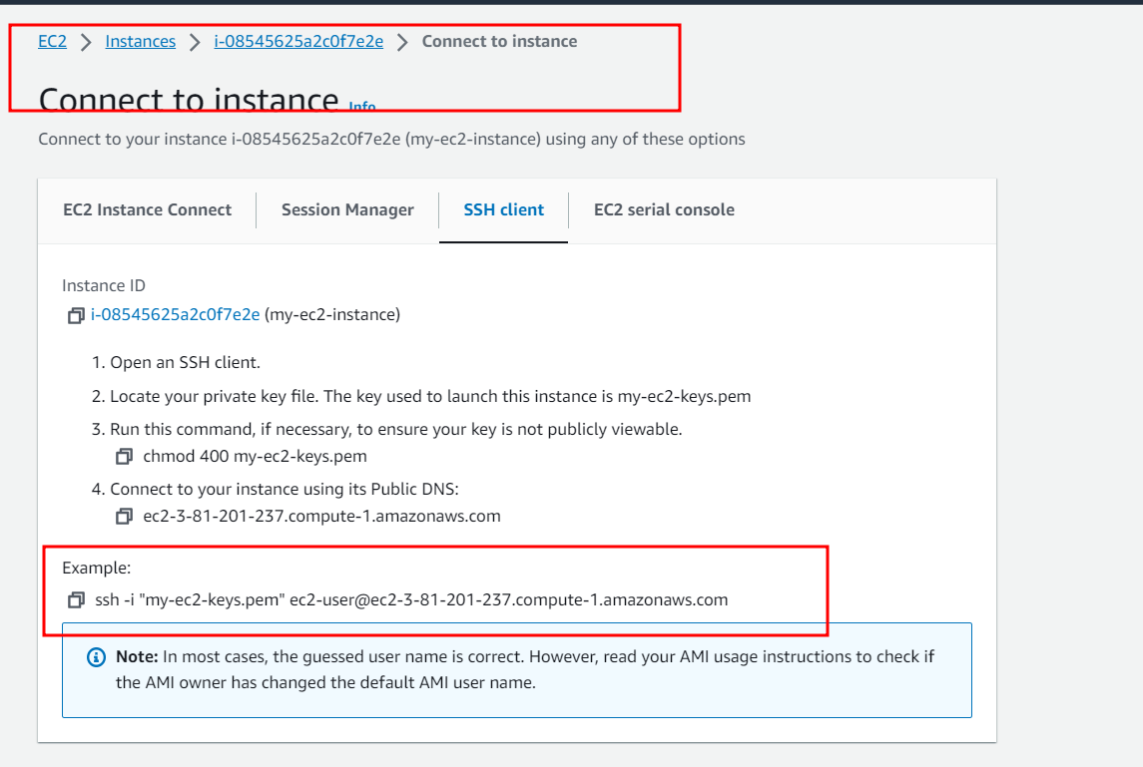

Please copy example ssh client commands

Then open git bash or normal terminal (but make sure .pem key file present int that location).

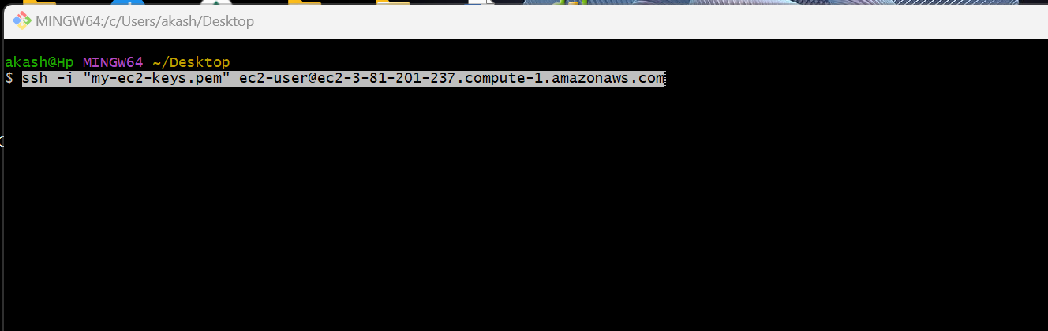

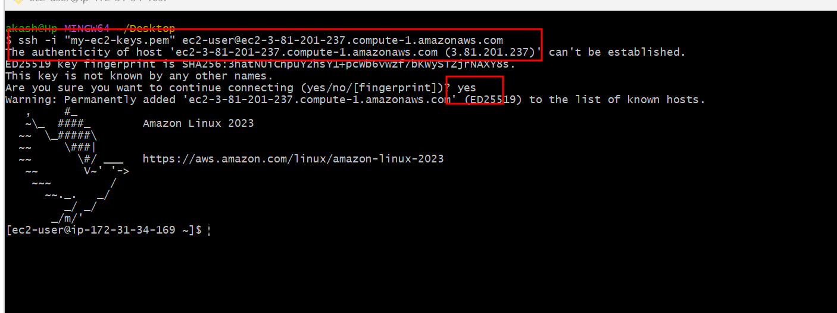

Now we need to install all required software in EC2 instance.

Git install

sudo yum install git -y

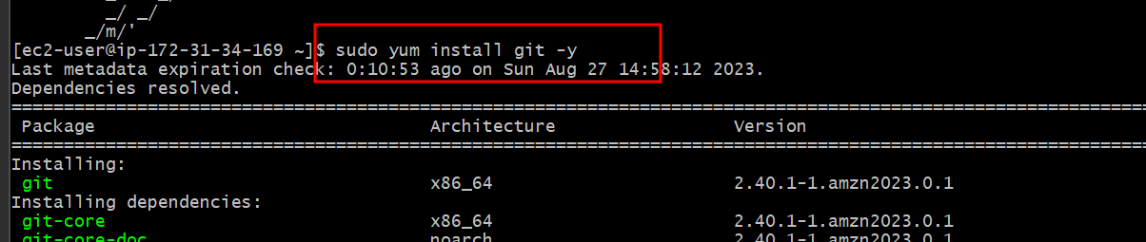

Docker install

sudo yum install docker

sudo service docker start

sudo docker –version

Docker compose

sudo curl -L https://github.com/docker/compose/releases/download/1.22.0/docker-compose-$(uname -s)-$(uname -m) -o /usr/local/bin/docker-compose

sudo chmod +x /usr/local/bin/docker-compose

